Keras Assignment

### **Problem Statement:**

Consider yourself to be Matt, who is a Deep Learning Engineer at a prestigious company. Your company is working with the National Institute of Diabetes to find out what are the factors which lead up to a patient having diabetes.

### **Dataset Used:**

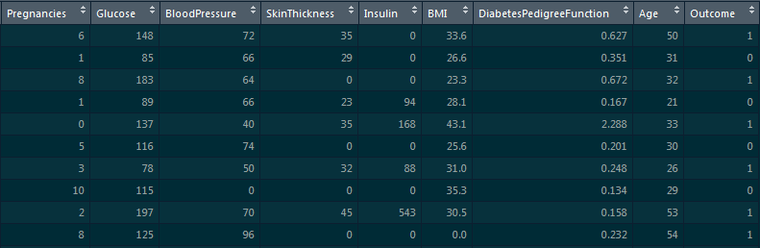

### **Tasks to be Done:**

1. Build a sequential model using Keras on top of this Diabetes dataset to find out if the patient has diabetes or not, using ‘Pregnancies’, ‘Glucose’ & ‘BloodPressure’ as independent columns.
   1. This model should have 1 hidden layer with 8 nodes
   2. Use Stochastic Gradient as the optimization algorithm
   3. Fit the model, with number of epochs to be 100 and batch size to be 10
2. Build another sequential model where ‘Outcome’ is the dependent variable and all other columns are predictors.
   1. This model should have 3 hidden layers with 16 nodes in each layer
   2. Use ‘adam’ as the optimization algorithm
   3. Fit the model, with number of epochs to be 150 and batch size to be 10